Company Profile

Arrowhead Technologies LLC (AT), founded in 2004 by Monte L. Hall is a professional laboratory specializing in the optical analysis of bulk building materials for the presence of asbestos by polarized light microscopy (PLM).
Our personnel have more than 40 years of combined experience in the asbestos laboratory and industry.
Mr. Hall has over seventeen year’s successful experience as Asbestos Lab Director for a top-rank engineering and consulting firm, Law Engineering/Mactec. During this time he achieved a reputation for excellence of his analytical work, for his strict Quality Control/Assurance procedures, record keeping, and a responsive relationship with his professional clients. Though his employer maintained several asbestos laboratories, critical or difficult samples were referred directly to Mr. Hall. He has more than sixteen years’ experience as an independent laboratory.
AT is accredited by NVLAP for Analysis of Bulk Asbestos Fibers by PLM (NVLAP LAB CODE: 200703-0).
AT has designed its service for the efficient support of professional asbestos consultants. Once the samples are signed into our laboratory, all the record keeping and reporting is completed electronically.
We have professional liability insurance for the protection of our clients from a highly rated underwriter.
Our Laboratory

The Lab is fully equipped with laboratory grade microscopes, sample preparation equipment such as safety hoods, stereomicroscopes, muffle oven, a full set of Calibrated Refractive Index Liquids, NIST Reference Materials and technical reference literature. This fully meets the NVLAP requirements per “The Method” (Method for the Determination of Asbestos in Bulk Building Materials EPA 600/R-93-116 and EPA Method 600/M4-82-020).
The laboratory also has photographic and microscopy equipment to support specialty analyses of paints, coatings, and material failures including photomicrographs of polished sections and stereographic images.

Our People

The Lab Manager and Analyst(s) are the backbone of the production. The Lab Manager directs the analytical operations and participates in the analysis. He or she is responsible for direction of Quality Control/Assurance. He is also responsible for direct relationships with the National Bureau of Standards NVLAP.
The performance of the Asbestos PLM method is strongly analyst dependent and relies on the skill, level of experience and care with which the analysis is performed. AT has designed its laboratory operations and personnel policies recognizing that the PLM method strongly depends on skill.
For this reason, the analyst must have adequate training in sample preparation, material types, and experience in the location and identification of asbestos in samples. This is accomplished through years of experience and substantial on-the-job training as well as formal education in mineralogy and microscopy. AT offers over forty years of sample experience and visual memory to apply to your sample analysis.
We require training from recognized providers and continuing demonstrations of competence through the NIST proficiency rounds, and intra-lab and inter-lab quality control rounds. In addition, analyst performance is tracked through our Quality Control program and re-training is provided when indicated.
The Bookkeeper is essential to support the efficient operation of our commercial laboratory; He or she is responsible for preparing invoices, recording payments and disbursing payments to vendors.
Our Product – Reports

Our summary report is designed to quickly “get to the point”. It identifies the Consultant (your company), the Project (and your project number), the person submitting the samples, the date collected, the date received at the Lab, the Analyst, and is signed by the Lab Director. The analysis method used and details of quantitation (CVAE or Point Counting) is specified.
Our laboratory system (The Laboratory Management System by Munch Technologies) also maintains details of the analysis identifying constituents as well as asbestos present in each layer. This report is produced on request to meet the NVLAP requirements for analysis by layers, which requires identification of each layer, fibrous components and other particles and binders.
AT’s system maintains this data in an on-line database, which allows prompt retrieval and reporting.

Office Information and Contacts

Laboratory (please ship samples to this address)
3151 San Bernadino
Clearwater, Florida 33759
Phone: 813-679-0720
Contacts:
Laboratory
Monte L. Hall, P.G., President/Lab Manager
Ryan D. Schwegman, Analyst
Rosemary Hall, Administrator
e-mail: mhall005@tampabay.rr.com

Website:
www.arrowheadplm.com

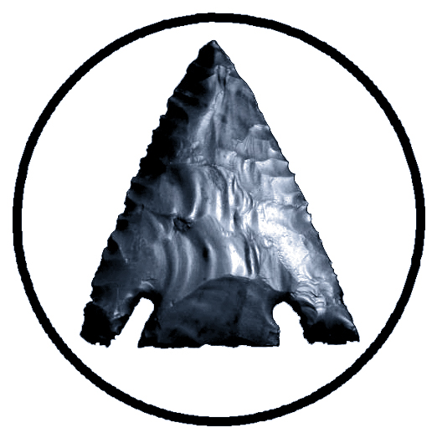 | Arrowhead Asbestos Laboratory  NVLAP LAB CODE: 200703-0
Arrowhead Technologies, LLC
Monte L. Hall, President
3151 San Bernadino St.
Clearwater, Florida 33759
813-679-0720 office (cell)
mhall005@tampabay.rr.com

AT Personnel Resumes

Monte L. Hall, P.G.
EDUCATION
University of Tulsa, BS Geology
Tuck Executive Education at Dartmouth
SUMMARY OF CAPABILITIES
Lab Management and Microscopy of Building Materials
AT maintains strategic relationships with Asbestos Consultants and Removers
REGISTRATIONS
Professional Geologist, Florida, #1658
PROFESSIONAL SUMMARY
Mr. Hall is the president of AT and his duties include management of the firm, technical oversight, as well as analysis. He has more than 30 years’ experience in the Asbestos industry.

AT Personnel Resumes

Ryan D. Schwegman
EDUCATION
University of Western Ontario, MS Geology
Oklahoma State University, BS Geology
SUMMARY OF CAPABILITIES
Microscopy of Building Materials, Data Management, Recordkeeping
CERTIFICATES
Asbestos Identification Using Polarized Light Microscopy, MICA 2019
PROFESSIONAL SUMMARY
Mr. Schwegman has a background in geology with well-developed research and analytical skills. His Master’s thesis consisted of extensive research, data management, and scientific analysis.

AT Personnel Resumes

Rosemary Hall
SUMMARY OF CAPABILITIES
Accounts receivable, accounts payable, billing and accounting functions.
CERTIFICATES
Asbestos Identification Using Polarized Light Microscopy, MICA 2016
PROFESSIONAL SUMMARY
Mrs. Hall is experienced with the accounting systems and has more than 30 years’ experience. She provides analytical assistance in the lab when needed.

